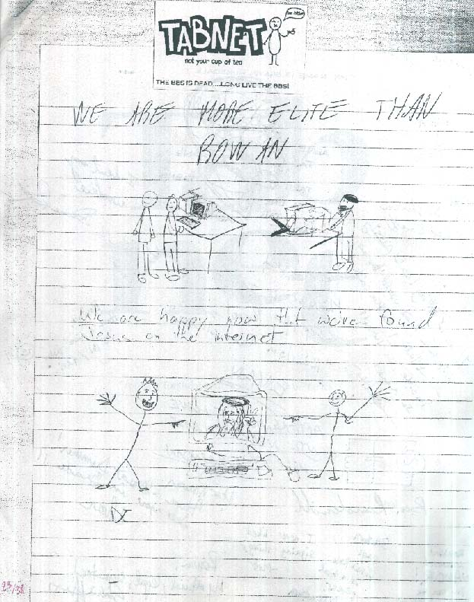
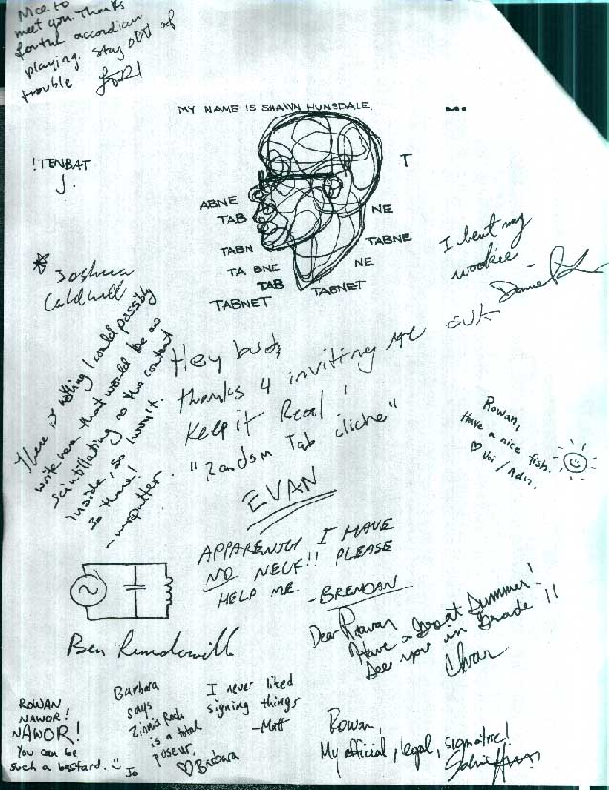

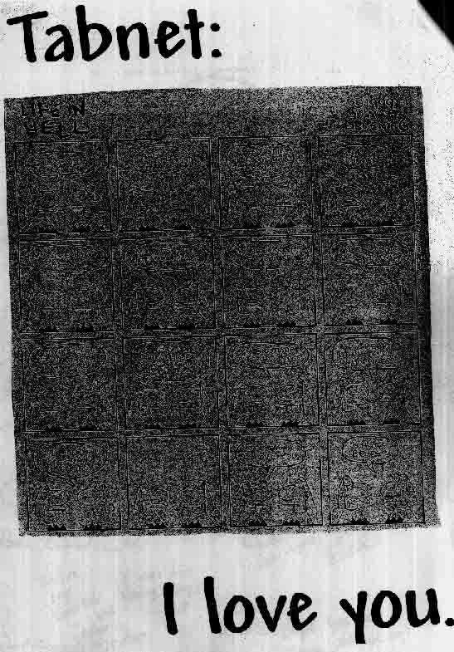
Tabnet 10-year anniversary meet
(or: the aw shit, we're OLD denture swap meet)

souvenir programme
August 17th, 2003

Contributors:
(closed-captioned for the new-school impaired)

Cthulu
Corinthian
Courtisan
Coyote
Dubaiwalla
Etana
Fiver
Fool (the Laughing Fool)
Frandroid (the Extremist)
Gomi (Beatle) (et al.)
Happyfish
Harry Sheep
IceCreamEmperor (Zamfir Worshipper)
Meija
Pannekoekologist (Merlyn)
Slimy
Soema (Wild Thang)
Ziola

(Digital re-release update: bonus material, footnotes, commentary and explication.)

Who did what? You must guess.

Editrix: Happyfish

--- GEcho 1.00
* Origin: Interzone (13:13/0)
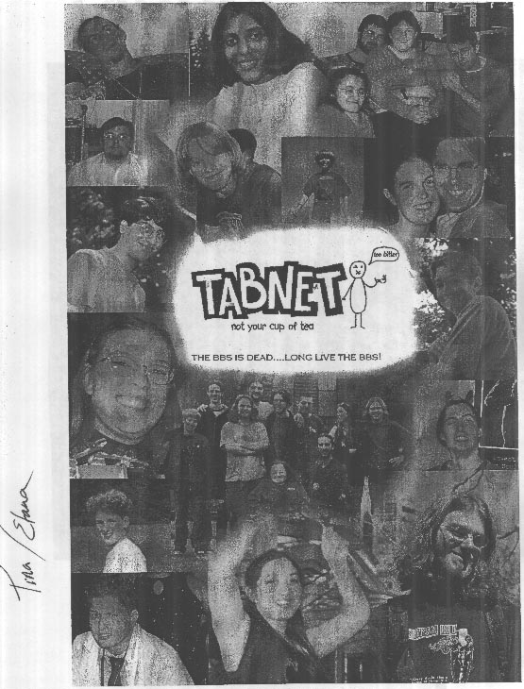
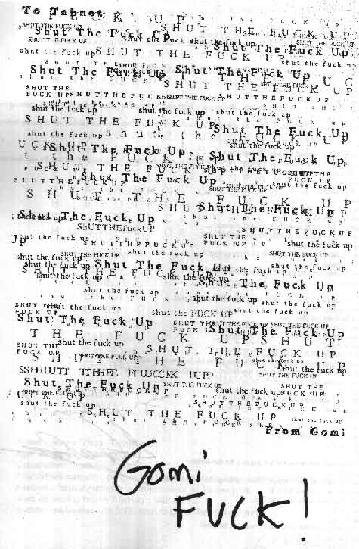
The Mail Must Flow! - November 23, 1998
(edited for space concerns)
<thext> i will go now. reading Dune Messiah inspired me a bit.
<Cthulu> inspired you to do what?
<Cthulu> become the next kwasatz haderach?
<thext> rowan - I have this tab parallel to dune set out in my head..
<Cthulu> i'm interested in helping out on that if it's more advanced than it was when you posted it on kitschnet 8)
<Cthulu> tell me more about tab dune.
<thext> "tell me more about loom(tm)"
<Cthulu> "HE WHO CONTROLS THE HOST... CONTROLS THE UNIVERSE!"
<thext> haha
<thext> more like parallelism between characters
<Cthulu> the mail must flow!
<Cthulu> you can tell the tabbers who've been posting the longest... from their prolonged exposure to sleepless nights answ[e]ring mail, it over time turns the whites of their eyes pure red...
<thext> me = paul muad'dib (or liet-kynes, if that is too much), barbara as lady jessica, josh as duncan idaho, you as gurney halleck, brooke as alia...
<thext> hhahaha
<Cthulu> masters with their chosen weapons, the bynkbats
<Cthulu> able to survive in an environment of barren emptiness (modem culture) without losing any vital content through their postsuits..
<Cthulu> hmn. brooke as abomination.
<Cthulu> works for me 8)
<Cthulu> who's feyd-rautha?
<Cthulu> brendan?
<thext> that'd do it.
<Cthulu> how about gordon?
<Cthulu> I've always felt that he was a kind of paul character...
<Cthulu> discrediting himself so that ankies won't worship him...
<Cthulu> through mass silly-posts.
<Cthulu> i'm interested in seeing the parallels of larger groups...
<thext> rowan - starting a jihad!
<Cthulu> the bene misteliaxu waging war against the ansi guild
<Cthulu> ANSIoam
<Cthulu> er...
<thext> cthulu - I'd see mist more like people of grabben and the pan..
<Cthulu> i don't recall that part
<Cthulu> but I read it several years ago.
<thext> city people on dune.. natives but not fremen
<Cthulu> hm, interesting.
<Cthulu> tabnet as dune.
<Cthulu> THE LURKER MUST AWAKEN!
<thext> rowan - i'd see shawn as feyd-rautha and hacker joe and his brother beast rabban =)
<Cthulu> i gues s you're familiar with brooke's appelation of the bonk base Sietch Tabbr?
<Cthulu> that sounds classy.
<thext> uv curz
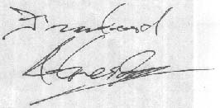
<Cthulu> I'm thinking of some sort of initiation we have...
<Cthulu> a Gom Tabbar...
<thext> Bonk Tabbar
<Cthulu> there ya go 8)
<thext> barbara of the bene universalis
<Cthulu> leto? (i and ii)
<thext> mYK?
<Cthulu> and howabout harkonnen and the emperor for that matter?
<Cthulu> mentats?
<thext> maybe it's time to slip bob eden in there... although he has no allies
<Cthulu> bob eden can be house ordos 8)
<thext> oh jeez yeah, josh as thufir hawat then
<thext> ordos.. hehhh
<Cthulu> stilgar?
<thext> the ordos are somewhat the game's version of the guild.
<thext> sylpheed
<thext> the fearless programmer
SCREW YOU TABNET!

E | T | I | L | E | L | M | N | E | R | P | T | P | V | B | P | N
K | N | T | G | M | H | W | H | Z | G | R | S | K | M | K | I | L
C | H | K | C | R | T | K | H | N | R | A | B | F | K | N | L | Z
H | C | X | A | Y | E | M | Y | W | Z | S | B | R | K | T | C | B
Z | L | T | F | Z | N | T | X | K | C | P | O | B | V | N | R | U
R | N | R | F | Q | B | N | F | A | H | F | O | M | A | L | E | T
E | N | P | E | N | A | C | V | C | E | B | H | O | T | C | P | T
D | B | K | I | G | T | E | R | R | H | S | U | A | P | M | A | E
R | I | N | N | T | N | C | I | A | I | G | B | L | M | P | P | R
A | T | M | E | G | O | W | Z | F | C | B | R | R | C | S | K | F
O | T | M | E | L | W | F | A | R | E | K | Z | C | Y | N | D | L
B | E | R | V | C | Q | T | D | N | E | T | L | N | N | I | A | Y
T | R | L | G | P | O | L | C | O | J | N | N | P | A | M | Z | F
A | P | R | M | N | W | H | N | V | O | E | O | L | L | C | R | I
H | J | R | B | O | N | K | G | M | B | M | U | C | T | W | V | X
C | Y | Q | G | N | I | K | C | U | F | P | X | P | K | W | R | J
H | G | G | E | L | A | T | O | N | A | M | A | Z | I | N | G | G

AMAZING  BBS  BENNYS  BITTER  BONK  BUTTERFLY  CABBAGE  CAFFEINE  CHATBOARDER  CONE  CRACK  DIALUP | ELITE  FANCLUB  FUCKINGQ  GELATO  IRC  NOTAFISH  PAPERCLIP  PITOFDOOM  POOP  SCAVENGER  TABBENCH  TABNET  WIREFORK

Name: Jenna "Ziola" Thomson
Age: somewhere around 24
Occupation: Liberry Whore
First tabnet memory: porn at the Stanley Park busloop before my first fireworks.
Favourite tabnet memory: post-fireworks at Tatlow park.
Most disturbing tabnet memory: Milk cubes
Sudden realization: it's 6:18, time to go to the Pit of Doom!

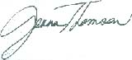
soema's submission. 6 august 2003

I claim i am a founding member of tabnet but the trust is it took a couple of weeks for me to jump from the burning remains of butterflynet to the oasis of tabnet and i became the 4th or 5th node or something. i didn't think it would survive. Beatle and Bluck and Incognito were the ones brave enough for the actual coup. It was an obscene accident. At times of introspection and analysis in the past i've wanted to remember the beginning better but recently i haven't. I was 15. The abstract claim is that tabnet saved me: I don't want reality blemishing the constructed and pure memory of that time.

So this cap isn't from The Beginning. Nothing, actually, remains of the very beginning, since disk space was extremely limited. I remember setting post limits of 250 messages on the active bases. Old posts would fall off the end after a couple of weeks. As of this writing, the 5 year old internet reincarnation (b0nk.org) has 8214 posts and 66082 replies. And that's with a database reset after the first year. In the beginning we didn't think of recording history because we were too distracted with the present.

This cap was taken very near the end of the echomail bbs days and the beginning of the internet days. This post was a departure for me. Instead of just spewing it into tabnet i copied it out into an email and sent it off to the girl it was about. This was the single event where tabnet was most influential in my life.

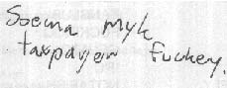

=-=-=- Arguing with Daryll (31:808/455) =-=-=-
=-=-=-=-=-=-=-=-=-=-=-=-=-=-=-TAB_ARGU =-=-=-=-=-=-=-=-=-=-=-=-
Msg : 214 of 214 Uns Loc
From : Soema 31:808/455 04 May 98 00:18:31
To : All
Subj : pome
=-=-=-=-=-=-=-=-=-=-=-=-=-=-=-=-=-=-=-=-=-=-=-=-=-=-=-=-=-=-=-=-=-

sunday may 3rd, twenty minutes after midnight

ode to open hand on her thigh

so like i stared at it while people read poetry at the sugar refinery tonight
and her beside me smelling like he rbeside me and i wanted to take her hand and
squeeze it but you know i won't lie to you i didn't take it, sure i put my arm
around her and hugged her at bennys as we waited for josh to buy his stupid
bagel, but i didn't take her hand and hold it with mine it would've been quite
easy, i touched it a couple times, just to let her know that i knew it was there
maybe she didn't even want me to hold it but all my experience in
interhumanbeing body language says that she was asking me to hold her hand and
i'm really swalling on it i wonder if she still feels like she does in that
letter that i have perched high on my white bookshelf that holds books and
books, next to my 1200 baud external hotplate you could cook an egg on that
thing, next to reiko's necklace, on top of maps of montreal and vancouver h er
letter sits, representing missed opportunity in the past now we dwell on missed
opportunity in the present i've said to many people i don't want to get involved
with anyone least of all people who i'm mildly nervous around scrambling for a
common topic of conversation but the skin on her cheek touching the skin of my
cheek and i so wanted to kiss her when i dropped her off just now but again i
didn't, why am i telling you this? why am i so scared of everything like this?

i don't want anything uncontrollable in my life right now, i'm still coming off
this school term, the worst thing you can do is stumble onto crap, hold her hand
you fucking idiot, no response, hold it, what's the worst that can happen?
shall i start at the beginning or the end of the list? you don't need this, you
know you don't want this or need this, but that letter, it can't've all
dissipated, you don't have anything in common, you don't have anything in common
with anyone, live in a hole, please, no, kiss her, kiss her, she came back to
the window of the car leaning out like an idiot you kissed her on the cheek and
said bye, she nervous and scrambling for words, you knowing that you would
regret this, if only everyone just said what they felt all the time instead of
having to write melodramatic run on sentences to a bunch of handles on tabnet,
who really cares anyway, melodrama is an escape, a glorification of stupid
crap, just like everything else in your life, just like everything else in
soema's life, just like everything else in myk's life, in mike's life, i'm going
to go sit on that chair, she said, follow me there, follow me there and hold my
hand that i have open and inviting on my thigh, don't think just hold the hand,
kiss me when you drop me off, and don't be a scared little idiot, grab some self
esteem and run, i don't know how to start things, i said to someone sometime
someday late at night probably over a steaming mug at a certain broadway bagel
brothel, i don't know how to start things with people, they always just come by
and initiate themselves, i don't have to do a thing, why did i hesitate, because
i wasn't sure, but her fingers on my ribs, the bent pink paperclip that has
since disappeared from the shoelace holes of my shoes, is it confusion? no, it's
hesitation, uncertainty, but not confusion, yes there is a difference, this is
rambling on, but vomit usually does, here's what would've happened, i tell
myself, you hold her hand at the sugar refinery on the couch, you kss her in
front of her house dropping her off last of course, she falls in love with you,
you fall deeper in love with her, you figure out that you have little in common,
the world ends, yes, you made the right choice, staying in your protected cocoon
of actionless desire, passive flirtatious bullshit life of crap, yes, yes,
pause, pause, do the vibes lie though? is this all blown out of proportion?
probably, but imagination certainly is an ego trip, heh, i even had a speech
prepared for her when i dropped her off, haha, i composed it while i was feeling
the arm hairs on her arm touch the arm hairs on my arm, i say to her hey
remember that letter that you wrote to me, do any of those feelings still exist
right now? no, she answers, that's very pretentious of you, and plus i was just
resting my hand open on my thigh because it was comfortable there
thanksfortherideseeyoulaterbye, yes, she answers, haha, wasn't that funny how i
didn't take your hand when we were listening to poetry earlier tonight, hold
still while i lean over and kiss you, haha, you're beautiful, haha, i'm leading
you on, setting us both up for a fall, ahha, isn't life weird, yeah, seeya,
seeya, i'm swlling on this to the point of it becoming really sad and

depressing, no, not really, cuz when you put it all out into words on the grey
and black 80x25 golded screen that you loaded up without even polling for
tabmail, when they're all out there everything is ok, because they're only
words, maybe it's because i'm freaking out about the change from school to work,
maybe it's the time of year, maybe it's my hormones, i should masturbate more,
then i'd be in control, then i would be the boss of me, ha, it comes down to
being too concerned with assumptions you make about other people, don't hold her
hand and kiss her even though you want to because she might want a lot more than
you're willing to get into at this point of life, and she'll get hurt, or,
perhaps, stop dwelling on that stupid hand, who cares, but the long hug in your
car, i don't know, i don't know how to end this, either, i don't know, i was
looking for a conclusion but it's all just uncertainty still, even as i drove
off, fuck, i wanted to turn around, even after i walked her home after that
party on saturday night, i rehearse and rehearse in my mind, but i always
chicken out at the last moment and say or do somthing stupid, sigh, and, and,
sat on your couch for 3 hours stroking your hair while you dozed on her, what
about 42, how much of 42 is a joke, most of it, but what about that little part,
i wonder how many minutes that is, what about beautiful beautiful girl who fell
asleep on you after the last drop of poetry had been read that late late night
here, and rowan sat on the black chair unincluded again, i don't know, heh, i
had an ironic conversation about cats today, i expressed an irritation with
pets, and caring eyecontact stolen glasses said to me, who freaks out more, you
or josh? me. i answered, affection, that's the key, you can masturbate until you
pass out and your keyboard no longer works, but pr0n can't replace warm flesh on
yours, holding you tight, like beautiful beautiful did as we left the party, as
she does when i drop her off down there on granville, and every time i see her,
the the hug i got tonight from a different her, as i dropped her off, i need to
get my bag from your trunk, drive off fast, i said, get away, get away, no, i
said, roll down your window and lean out, you now have another chance to kiss

her, but, of course, i didn't, this is repeating itself, i don't know what more
to say, maybe i should get a cat, shave it bald so i can breathe, thenmaybe i'll
stop falling in love with everyone.

yeah.

mike.

--- UNREG
* Origin: subliminal reality three? no. (31:808/455)


("A band that doesn't suck yak toe.")
(New and approved by Joe Naylor!!)

Wednesday, November 22, 1995
Doors at 6:00pm, Muuuuzak at 7:00

Cameron Rec Centre
ALLLLLLLLLLLLLLLLLL AGES!!!!

Cameron Rec Centre?!??!?! Where the fuck is that??? YOU CAN'T GET THERE FROM HERE!!! Ok, calm down and listen to me. It's very very easy to get from anywhere to The Cameron Rec Centre. First, you will need some supplies: Some money for tix (Probably around $2-4); some money for the bus, if that is your desired method of transpo'tation; some clothes; etc. Here's how to get there from UBC by bus: First, meet up with Adia and Geradine, so you can all go in a biiig group. Walk from wherever you are to the UBC Bus Loop. This is located about 513.23 metres away from the Arts One Shack, about 23.4 degrees east of north. When you find it, rejoice in your accomplishment and draw strength from it, you have a long journey ahead of you. You must get aboard a bus with either the number 10 or the number 4 displayed on the front of it (note that the numbers 10 and 4 are both numbers of satan.) After awhile, maybe 42 minutes and 23 seconds or so, you will find yourself in a mysterious and extraordinary place called downtown Vancouver. WARNING: If someone asks you if you want to buy crack rock, JUST SAY THE FOLLOWING: "no, thankyou, I'm going to a great concert, besides, drugs are bad." Then run away. You will need to find something called a Skytrain. This train, which one would think would be in the sky, is buried under the ground. Don't ask. Once you find the Skytrain, you must get on to the Skytrain going to Surrey. DON'T WORRY!! You will not enter Surrey! This is a hoax by the people that invented the Skytrain to discourage people from using that train. (These are the same people that called it a Skytrain and then buried it far beneath the ground.) (ps, if you do end up in Surrey, and someone runs up to you holding a chainsaw, just say: "no, thankyou, I'm going to a great concert, besides, drugs are bad.") When you are safely aboard the Skytrain, you must now have a conversation with the wonderful people you are travelling with. Possible topics of conversation include: Dr. Naylor's black shoes, Dr. Naylor's green shoes, Dr. Naylor's socks, and crack rock. You must also decide where to exit the skytrain. You are here presented with three choices: Get off at Metrotown and take the 154 to Lougheed Mall (making sure that you do not take the bus saying "Municipal Hall"); Get off at 22nd street station and take the 154 to Lougheed Mall (I'm looking at the big transit map right now - Don't blame me if these buses stopped running in the early eighties); Get off (and this is probably the most preferred choice (fastest) - shut up, get yer mind outta the gutter) at New Westminster Station ant take the 147 or 148 Bus to Lougheed mall. A small warning about Burnaby malls: Malls like Lougheed and Metrotown are infested with a peculiar breed of humans called Homies. Homies are always found in groups, have an average jean leg radius of 12540.2 cm, and use expressions like: "'sup bitch h00k me up with sumadat sheeeat" This means, losely translated, "I would like to sell you some crack rock" If you hear this from any homies, simply respond with the following: "no, thankyou, I'm going to a great concert, besides, drugs are bad." and then step on them.... Once you arrive at Lougheed Mall you will need to find the Cameron Rec centre, which is located North (Up) from the Mall, on a street called Cameron (go figure.) It will take you about 6 minutes and 56 seconds to walk from the Lougheed Bus loop to Camon Rec Centre. The best bet here is to ask someone how to get to Cameron street, and then, if they answer without saying 'sup, ask them about the Rec Centre. It's not hard to find. Also, it is attached to a library, and appropriately labelled. Take this into consideration when trying to find it. When you get there, go in. You will probably see someone sitting at a desk taking money. It might not be a desk though, it might be just a chair. Like, who's to say, right? Tell the person that is taking money for tickets that you are "with the band, man." They will let you in free. Then, enjoy the wonderful music by everyone's favourite band, CASA DEL SOL, followed by Makeshift (call them Crankshaft and they will beat you,) and a band called Fiend, who might not suck any more.
If you have ANY questions, please call me (Mike) at 524-6040 - if you get my lame answering machine, LEAVE A MESSAGE. Right. I'll see you there maaaaaaaaan

michaelw@unixg.ubc.ca
C:\BODY\WPWIN60\WPDOCS\CASADSOL.BAN
11/20/95 22:29
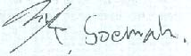
Untitled

From: Courtisan
Received: 08/02/03 01:09 AM
I believe Rowan posted this... it's been in my archive for a looong time.

Apparently, in germany, a man got locked out of his house...

so, he tried to get in, through the cat door.

He got stuck.

He yelled, he screamed, but his cries only served to attract the attention of
a roving band of merry pranksters, who took the opportunity to remove
his
slacks, paint his buttocks orange, and plant a daffodil where the sun don't shine.

They then proceeded to write a sign explaining that the man was a performance
artist.

For two days he was applauded and had money thrown at him.

THIS IS ART!!!!!!!
(for inclusion in the tabzine. if you could tag it Slimy, that'd be gnarly)

Once upon a time, in a very temporary blip between unwired and globally wired, there was a frighteningly odd and enlightened bunch of freaks and explorers tickling technology out of curiosity and betterment, rather than purely for profit and career goals. There were lessons learned, brain processes rewired, and the remainder that time spent offline with people means a great deal.

On thinking back, here are some flashbacks of influence on later life (in no particular order):

---- 8< ----

Tfiles were a succinct, dangerous and now expired knowledge source

Thinking, not fighting, was an exit to enlightenment from suburban drawl

Naked Beatle gave me the gay

There's no need to stagedive at Christian rock meets

Bluck flying a peanut butter cup over Vancouver

STS chat boards were the electronic version of Surrey

Happiness can be found living by the word of Nuiwanda

My bum foams

Watching the tabfreaks grow up to be better off than most of society as proof that normal wasn't better

[toomuchlsd]
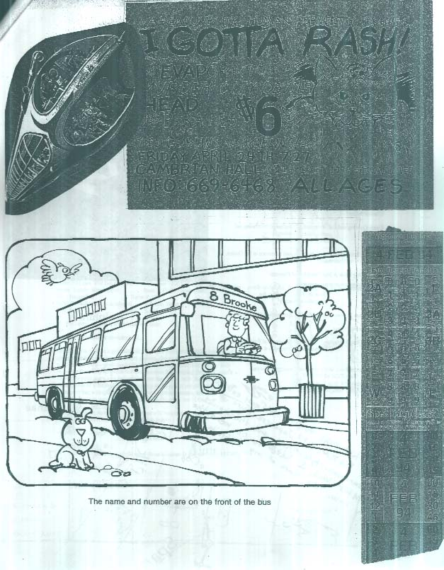

Date: 10:04 pm Fri Oct 9, 1998 Number : 1003 of 1004  From: Zinnia Kray Base : (Tab) Sietch Tabber  To : All Refer# : None  Subj: ASSIGNMENT #3 Replies: None  Stat: Sent Origin : 09-16-98 21:34  SUBCULTURAL STUDIES AT TAB U.: TABCULT307  Final Paper  This paper is due on November 10th and is worth 37% of your final mark. Papers will be collected fro my mailbox at 8:30 and 3:30 every day and date stamped accordingly. Late papers will receive a deduction of 10% for each day late.  Possible Paper Topics: Suggested Themes and Titlse  It Gots Ta Be Funkay: Tabnet and the Meaning of Culture  Larry Is Us: Self-Definition and The Other in Tab-Centred  Discourse  Whither Ahom?  Blank-Quoting and Self-Restraint (a technical/psychological  paper, behaviourist-style  animal testing encouraged)  Carpe Girl-em: Insecurity, Self-Image and Romance in the Online  Community  All Over My Face: A Not-Too-Modest Proposal  Why Computer Geeks Are Good In Bed (dumbed-down version of "All  Over My Face..." written for  a popular audience.)  "Mysterious Figures" and the Social Construction of Excitement  Angst, Be Not Proud  Rowan's Ass, Josh's Ass, Mike's Ass: Homosexual Posturing As  Heterosexual Competition.  ... let's ignore them. let's powder our noses. powder our  ___ Blue Wave/DOS v2.30 [NR]  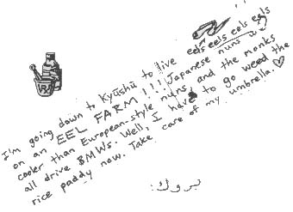  --- Renegade v98-101s Dos  * Origin: a song for no one (31:3373/0) | 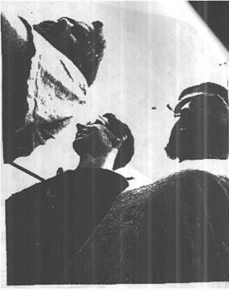  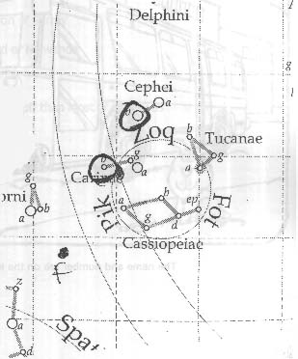

Date: 2:56 am Mon Jul 13, 1998 Number : 1001 of 1001  From: Crowkeeper Base : (Tab) litrachur  To : Cthulu Refer# : None  Subj: <--- Replies: None  Stat: Sent Origin : Local  Well, I see little here has altered...  Look what you've reduced me too [sic] Rowan.  I wish very much that you would answer your accursed e-mail.  <tap>  <tap>  <tap>  Oh...And my most saccharine and specious greetings to the  rest of the gallery.  I've missed all your spiritless and misguided angst...Truly, I have.  ta, ta...  Ever with regards:  Crowkeeper (Cornelius Scarecrow esquire)  ... Mono no aware wa shirue  ~~~ ReneWave v2.00 [NR]  --- Inclement Weather Soup  * Origin: one eye filled with blueprints (31:3373/0)  Date: 2:21 pm Tue Jan 6, 1998 Number : 1005 of 1005  From: Zamfir Worshipper Base : (Tab) Sense (non)  To : Happyfish Refer# : 999  Subj: Re: subjunctive conjoncti Replies: None  Stat: Sent Origin : Local  H> For better or worse, it's tabnet lore now.  H>  H> Fuck, is that ever melodramatic.  One day, you will be a grizzled old lady on a parkbench with a bag full of  strange, archaic objects -- concert posters, ticket stubs, printed scrolls  with strange texts -- and the foolish, unwary or hopeful will stop by your  bench on their way to and from their various high-paying jobs, and toss a  fournie in your worn and tattered bowler hat. Then, with the great  deliberation of a museum curator lifting an Egyptian papyrus, you will take  from your bag a single object, present it to the spectators, and explain  softly it's [sic] various uses and relationships in the great world that was Tab.  Some will weep, some will laugh, some will return day after day after day, but  all will be touched by that 'crazy old Tab lady'.  <violins strumming>  --- Renegade v5-11 Exp  * Origin: I can't hear you, I have these bananas in my ears. (31:3373/0) | 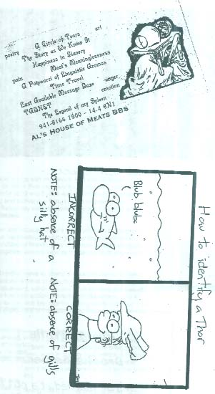

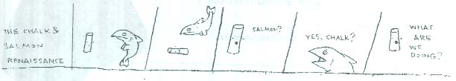

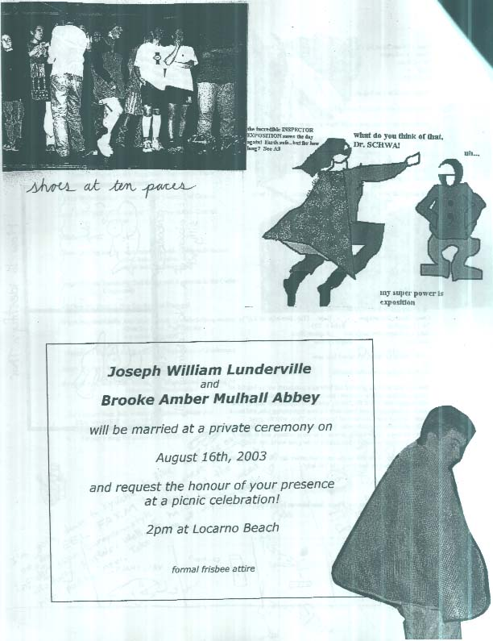

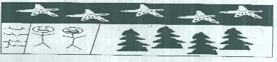

i was 15 or so, spending my free time doing random stupid things with my friends in the suburbs and fumbling through dreams of punk rock stardom (playing for more than my friends). for the past year or two previous i'd been spending a lot of time in front of my tandy-1000 and 2400 baud london drugs special. initially i found textfiles and warez to be the most exciting and subversive thing i had ever seen. soon, i realized that games were boring and the "anarchy" text files rarely actually worked. i started exploring the other areas of the bbs' only to eventually stumble upon tabnet.

i'm not going to build up tabnet or reflect on how great we are because there's too much of that going on constantly and it makes me want to throw my monitor out the window, but lets just say that tabnet was definitely there to help save me from becoming like my childhood friends. kids who were content with just sitting around, doing drugs and not paying attention to anything around them or content to sit in class and only learn what was taught in school. thanks everyone.

so, like i said earlier. i was around 15 and finally worked up the nerve to attend a fireworks meet. my friend keith and i showed up at the stanley park bus loop to discover a mass of people sprawled out under and in the trees. i walked up and sat down, totally nervous and awkward. within minutes, i felt comfortable enough to speak to people and had probably the best time i ever had with tabfolk. i hassled chatboarders, only to end up with some 13 year old girl calling my house daily for the next few months asking me to date her. I lay on my back watching the fireworks, for some reason the explosions never seemed as huge as they did that night and never have since.

afterwards, eager to get back to the skytrain to catch the last bus back to langley, keith and i took off in the direction from which we thought we came. we walked and walked and must have been walking for a long time and talking pretty heavily because before we knew it we were alone, under the lions gate bridge and somehow it was now 1am. we panicked; neither of us had really ever been in stanley park before, let alone at night. somehow we ended up in the zoo, deserted, dark and really really creepy. we were sure that at any moment, we were about to be attacked by one of those crazy city-folk and end up food for the polar bears (who probably weren't even in the zoo anymore by that point).

at around 2:30 am we finally emerged from stanley park without having had our limbs gnawed off by hungry animals and raced up the street to the skytrain station. it was closed. we were in trouble. we entertained ideas of sleeping on the street in gastown or catching random busses and just riding them until they made us get off, but finally i decided it was probably a better idea to just call my dad who laughed at me hysterically and drove out to pick us up.

that was great.
dan.meija.6o4
august 6 / 2002
danny@dancingrevolution / www.dancingrevolution.com / www.paper-lanterns.com
Excerpts from The Hitch Hiker's Guide to the Galaxy

"There is a theory which states that if anyone discovers exactly what the Universe is
for and why it is here, it will instantly disappear and be replaced by something even
more bizarre and inexplicable. There is another theory which states that this has
already happened."

"The Babel fish," said the Hitch Hiker's Guide the Galaxy
quietly, "is small, yellow and leech-like, and probably the
oddest thing in the Universe. It feeds on brainwave energy not
from its carrier but from those around it. It absorbs all
unconscious mental frequencies from this brainwave energy to
nourish itself with. It then excretes into the mind of its
carrier a telepathic matrix formed by combining the conscious
thought frequencies with nerve signals picked up from the speech
centres of the brain which has supplied them. The practical
upshot of all this is that if you stick a Babel fish in your ear
you can instantly understand anything said to you in any form of
languages. The speech patterns you actually hear decode the
brainwave matrix which has been fed into your mind by your Babel
fish.

"Now it is such a bizarrely improbably coincidence that anything
so mindbogglingly useful could have evolved purely by chance that
some thinkers have chosen to see it as the final and clinching
proof of the non-existence of God.

"The argument goes something like this: 'I refuse to prove that I
exist,' says God, 'for proof denies faith, and without faith I am
nothing.'

"'But,' says Man, 'The Babel fish is a dead giveaway, isn't it?
It could not have evolved by chance. It proves you exist, and so
therefore, by your own arguments, you don't. QED.'

"'Oh dear,' says God, 'I hadn't thought of that,' and promptly
vanished in a puff of logic.

"'Oh, that was easy,' says Man, and for an encore goes on to
prove that black is white and gets himself killed on the next
zebra crossing.

"Meanwhile, the poor Babel fish, by effectively removing all
barriers to communication between different races and cultures,
has caused more and bloodier wars than anything else in the
history of creation."
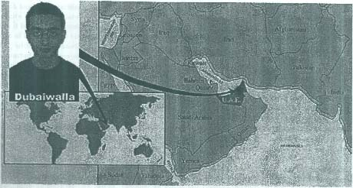

Selected quotes from Tabnet:

Rorschach (tabber 250)
You do enjoy some things, right? Or are you just a pretty hate machine with a guitar?
gomi (tabber ninja 3k)
no i hate everything except breathing...
sometimes i hate that too.

Rorschach (tabber 250)
Wow. Are you all just bitter Bauhaus listening snooty mucky muck vegans or what?
When did tabnet turn from the Adopted Bastards Network to the All Bitching Network? I mean, I
post about the stuff I like, just like the REST OF YOU.
Just because it concerns pop-culture and whatever, doesn't make it any less interesting. Some
people actually have other interests than:
1. OH MAN! My life sucks.
2. FUCK! My life sucks and OH SHIT Weezer's in town! I LOVE WEEAZER! YAY W
WEEZER!
3. HUNGRY! Where's a place that caters to my vegan and neo-christian needs?
4. Insert snappy Gordon thread here.
5. MEET! Let's go somewhere and EAT VEGAN FOOD! Oh SHIT...RADIOHEAD AND
SIGUR ROS are in TOWN! I WANT THEM TO HAVE MY BABY!
6. So, I saw the new Sta...SHUT THE FUCK UP. Now, who wants to get some non-dairy tofu
non-cheese and rent something involving angsty cows? YAY COW ANGST!
Again, I have NEVER EVER attacked anyone's opinions or likes or dislikes.
So, inclosing, I heart tabnet.
mrputter (tabber elite 1k)
> When did tabnet turn from the Adopted Bastards Network to the All Bitching network?
A long time ago, buddy, in a network far far...
gomi (i like you)
if you want to go and cause mayhem (serving yourself, sitting in the big
chair, sitting on the wrong side, talking to the girls, talking our of turn etc)
let me know, it would be a fun tabmeet.
Tabnet Vs. Krishna

colour (tabber)
Hehe... yesterday I was realising that it's likely our kids will ask us questions like, "What was it
like before e-mail, Daddy?", and that many of us will have an answer for them.
IceCreamEmperor (tabber elite 2k)
We'll have an answer, but it won't be a true answer -- it will just be an opportunity to project all
our criticisms of current communication retroactively back on history, in order to bitch at our
kids.
Cthulu (tabber ninja 4.5k)
fuckin' kids
don't know how easy they got it, able to emulate c64 games on their playstation 3 without
actually having to put up with c64s
grumble grumble
mrputter (random aura)
> in order to bitch at our kids.
In six feet of snow.
Uphill both ways.

gomi (TaBG(0)D)
i'm a secret agent by day, and a sleeper by night.

gomi (i amf reaking o UT FREAKING OUT!!!)
>Do I have to do a fucking sarcastic BALLET?
ah one
ah two
ah one two three four

IceCreamEmperor (something a little stupider)
[W]hat Francois was saying was that the nature of Tabnet is to be sarcastic and bitter. So suck it up.
arts anti gamma (cute and nice)
So suck it up.
SLLUUUUUUUUUUUUUUUUUUUUUUUUUURRRRRRRRRRRRRRRRRRRRRRRRP!
Aaahhh...

Soema A (one moment, one chance)
DELETE EVERYONE WHO DOESN'T COME TO MEETS. (adendum: ..and thinks they have a
right to comment on this community. delete delete.)
<This is about the point where I ought to start whining to Myk again about being discriminated against>
AHOM excerpt from "Have Penguin, Will Travel", Rowan Lipkovits' 3-day-novel of ... 1996?

It was with immense gratification that he stopped in front of a garishly painted restaurant.
It was quite garishly painted. It was also a restaurant. It was quite a garishly painted restaurant, in fact. If it looked like it had been painted in sections by the individual busboys and waitresses who worked at it, in the styles and colours of their various temperaments, it was probably because it had. The architecture could only be described as anarchic, with various booths and tables accompanied by all manner of chairs and stools. The building itself had been constructed by a team of students who decided that they wanted to work in a restaurant to pay their tuition fees but couldn't get hired anywhere else on account of their wild, shocking, unkempt and nonconforming appearances. There was a raw, unfinished patio, and above it hung a great big neon orange sign which said, "Al's House of Meats". Beneath the sign hung the flags of France, Canada, the United States, one with a happy face on it, one with a marijuana leaf on it, and the Jolly Roger. Clark took both the English name and the American flag as indications that he could be served by an English-speaking waiter inside, so he rushed in, ready for some meats.
The penguin followed.
Clark sat in a rocking chair, waiting to be seated. Across from him was a wide array of coin-operated candy machines, palm reading machines, grip testers, and large stacks of free 'zines and publications were heaped around the bases of these various pieces of equipment. Clark adjusted his position so as to allow more light from the ambient lava lamps to pour over his shoulder and picked up the first paper that he could reach.
It was printed on rough yellow paper, and, not surprisingly, was advocating the decriminalisation of hemp for construction uses such as this very paper. After a few paragraphs of listing the god-sent abilities of the misjudged hemp plant, such as strength, durability, easiness to grow, the testing which proved that it cured most forms of cancer, and the fact that wearing clothes made from hemp fabric made you more attractive to women, the main body of the text degenerated into paranoid ramblings about government regulating, conspiracies involving the Catholic Church, and "mOOOO says the cow. moOOO." Clark decided that it would be prudent to put the paper down and try for some more mundane literature.
Picking up the next closest magazine, printed on glossy paper, he was most distressed to discover that it featured a young man in bondage gear on the cover, complete with dog leash, spiked collar, and nipple clamps. Eager to return the shocking pamphlet to its pile yet morbidly fascinated with the contents of the underground mag, Clark simply couldn't manage to put it down. His attention only wavered when, after several minutes, his reading was disturbed by a waiter, who was here to seat him.
"I love you," said the demure tall young man with short blonde hair and glasses.
Clark frantically looked up at the speaker and tried to conceal his literature of choice behind his back, but the garcon would have none of that.
"Fascinating, isn't it?"
The man was looking at Clark expectantly, as if he hoped to hear a well-thought critique of the realism and clarity of the pornographic photos. Clark started to mutter denials of having looked at the magazine, that he was only glancing at it.
"Don't be ashamed... go ahead, keep it. They're free. Now if you'll just follow me to your table...?" The waiter gestured towards a brightly illuminated table beneath a wildly polka-dotted ceiling fan.
Clark discreetly left the S&M newsletter on the rocking chair and followed the tall man, who was wearing a nametag reading "AL." He sat down as the waiter pushed a kiddie's high chair up to the other side.
"For your penguin," he indicated, as if it was an obvious oversight.
Lifting the penguin up into the seat, he then introduced himself.
"My name is Ivar," he began, paying blatant disregard to the nametag, "and I will be serving you tonight. Here at Al's House of Meats we communally wish you to have the most enlightening eating experience possible under the given circumstances. As such, if anything at all inconveniences you in the slightest, please feel free to signal to me, or any other employee here. We believe that we are here to serve you, our customer, and as such, cater as much as possible to your every need."
"Excuse me... I couldn't help but hear when you came in that you said that you loved me. Was that... simply an extension of the comforting atmosphere you are trying to present here?"
Clark's logic lobes were working overtime to make sense of the wildly varying information he was being presented with, and he was doing his best to cope with what he believed to be a sincere expression of unrequited love and admiration.
"Actually, I only do it for the shock value, to see how you'll react. Most people simply ignore me and pretend that it was never said. Now, of course, you'll be needing a menu."
At this, "AL" turned around and disappeared for several minutes. During his absence, it seems that a fight broke out in the kitchen, as there was much screaming from that direction. One female voice kept stating that she wasn't going to listen to him, and a bitter male one kept insisting on his right to be heard. A second male voice soon joined the fray, and the conflict culminated with the bitter man being led, still wearing the apron and holding a spoon in his hand, out of the kitchen and out the front door into the street by a large woman and a short blonde man. As soon as they had gotten him out of the restaurant, the pair gave each other a high-five, the man turned a bolt on the door, and they retreated into the kitchen. Clark
noted that they, too, had nametags reading "AL".
The other patrons of the restaurant appeared unperturbed by this little confrontation with the cooks, and quickly went back to their discussions about public transit, pot smoking, and alternate forms of government after witnessing the third cook outside yell a bit in frustration
and lie down in protest in front of the doors.
Ivar returned bearing a menu and a small box. He presented the menu to Clark with a grand flourish and set the small cardboard box gently upon the tablecloth. Clark opened the menu and was surprised to see nothing.
"Yes, yes, I know, you're going to complain that I have given you a blank menu. You will note-"
"No, no, that's not at all what I was going to ask, at least, not quite yet. Does that sort of thing with the.. er... cooks happen often? They seem to have had a bit of a... spat. But when you're done with that, the menu question would make a great follow-up, yes."
The waiter took a deep breath, sorted his thoughts, and continued in what sounded like a rehearsed voice.
"Al's House of Meats is an experimental restaurant, from the very construction itself to the methods of food procuration and preparation, all the way down to how it's run, i.e. where the money goes and who decides all that. It being run by a commune of students, we have experimented with various forms of self-government. The communism phase worked well at first, but then as we ran out of natural resources some members ended up wealthier than others, and that fell apart. No one wanted to visit us during our attempt at fascism, as the atmosphere was too oppressive, so we've settled on a rough anarchy. People settle their problems by themselves and, though not
everyone is happy, they're all given their chance at providing themselves with joy. Now as for- "
"Just a second here. Haven't you people tried a democracy yet? A genuine capitalist democracy, like the real world is run?"
Clark found himself incredulous that these kids had gone to all these extremes in an effort to be hopelessly fair and give every system a chance. At the mention of the word "capitalist", however, Ivar rolled his eyes, in the realization that he was dealing with a relative inept in the worlds of global socio-economic trends.
"I would give you a clear answer stating why a capitalist democracy cannot work inherently, but it would take longer to explain than it would for you to eat your meal. Now, as for the menus... we feel that there is no way we can give you what you want unless you tell us exactly what you want. As such, you fill out your own menu. And to facilitate the creative process," and here he opened the cardboard box, "we have provided you with an assortment of crayons."
"I'm afraid," began Clark, "that I've had a rather unusual week, and I simply can't deal with this restaurant at this point in time. I pray you'll excuse me, thank you for your time and the wonderful conversation, and will quietly leave."
"Don't feel bad," replied Ivar cheerfully, "many people have to visit the restaurant five or even six times before they can work up the nerve to order something."
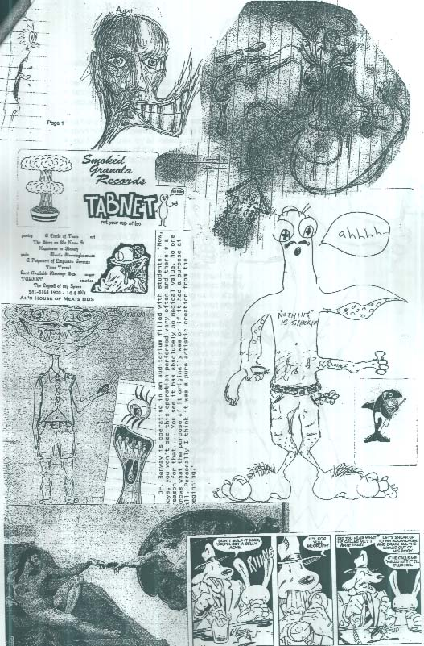
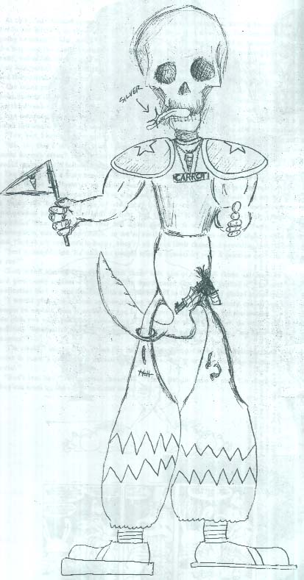

> hello brooke.
> benn here. rowan is insisting that i send you things.
> tabby things. for your retrospective . or reunion
> package. whatever it is.
>
> so here's what i've been able to scrape together on
> short notice. if there's anything in there you think
> you'd like to use, by all means do so. but i must
> warn you. none of it is especially good. in fact
> it's all tripe. consider yourself warned.
>
> as always,
> i am benn.
>
>
> ***
>
> MAC FLECKROW
> (September, 1995)
>
> All penguine things are, to wit, fileted,
> And when they summon, Concrete must obey.
> This Fleckrow found, who like Erasmus hearty
> Was called to Benny's, mistaking us for a party
> Of Poes and Burnses all round, without acute
> Singularity or sufficient cause for refute.
> An aged canine, blasted now with sensibility,
> Coyote thus was foolish in his flourish'd tyranny,
> And lost his goodly grip on all things sane
> While laughing on a hill the Fool one came.
> So, pondering which of the songs of bitches
> Ought to reign, we saw Mortal Kombat, he twitches
> and cries: "Boys in skirts being the purpose of this meet
> Let's go to the library and find out which bugs are good to eat!"
> Ct--- alone the perfect image bears,
> Mature in silliness, scream the corns of his ears:
> Ct--- alone of all the Tabbers is he
> Who stands confirmed in full surreality!
> The rest attempt, cajole or marinate
> Their rightful title as Elitist Bastard Laureate.
> But Ct---'s poetic wit denies no game,
> For his running commentary earns the name.
>
>
>
> I HAD A DREAM AND YOU WERE IN IT.
> (June, 2001)
>
> we were both dreaming and we both knew it.
> we were in a ballroom.
> i approached you and asked you to dance.
> you said yes.
>

> you were beautiful, but you were tired. exhausted.
> i put my arm around your waist, you put yours around
> my shoulder.
> halfway through the first number, i realised you'd
> fallen asleep on me.
>
> wanting to dance with you had been an all-consuming
> desire,
> and it was with
> no small disappointment
> that i led you off the dance floor.
>
> so we sat on a bench against the wall, off to the
> side.
> we watched the dancers waltz in perfect unison.
> you put your head on my shoulder and fell asleep.
>
> you never told me your name, but i was happy.
>
>
>
>
> a short poem
> (June, 2003)
>
> i drink the strongest coffee,
> cup after cup,
> until my head explodes -
> my heart palpitates -
> and the strangest bon mots become part of my
> vernacular.
>
> what are your plans?
> sell me your plans.
> make me an offer you couldn't refuse.
> i'll buy the brooklyn bridge.
> i'll be the eskimo you sell ice to.
> just don't leave me hanging -
> swinging in the breeze
> from the highest branch.
>
> a grifter on a bad day,
> a complacent confidence man,
> a grinning devil with a mouth full of gold,
> and spittle.
> very sly.
>
>
>
> ON BEING SEVENTEEN
> (July, 2003)
>
> I wait for you on a bench at the train station.
> Sunlight slants in through the windows
> striking dust motes dancing in 5/4 time
> just in front of my eyes.
> But strangely, when I looked outside a moment ago
> it was raining.

> The two of you arrive in a flurry of words.
> Every encounter is like catching a snatch of airborne
> conversation;
> No beginning or end,
> just
> everlasting ideas.
> One after another.
>
> Mostly, I listen.
> You two are like alternating current
> while I am the grounding prong.
>
> We walk out of the station
> and down Terminal Street.
> I have nothing to contribute to your discussion
> which revolves around Henrik Ibsen and VAX.
> I feel faintly self-conscious
> and wonder why I am there at all.
>
> Then, without warning,
> the conversation turns to other matters.
> Projects, current and future.
> Play-acting on public transit.
> Causing a spectacle. For the sake of art.
> Time capsules.
> Nootropics.
> Mind viruses.
> Two hundred and fifty natural highs.
> Photography.
>
> My head spins as I try to keep up.
>
> We catch the number eight to Granville Street.
> You get on ahead of me
> while I follow.
> We find seats at the rear of the bus
> and I pull a permanent marker from my pocket
> to write her name in grafitti on the back of the seat
> ahead of me.
>
> The ideas come fast and relentless
> but I'm no longer paying attention.
> I wonder where they day will take us.
>
> Between the raindrops are spun webs of sunlight.
The Mercurial
MAD MILLINER'S
SOCIETY
A R o y a l H e r m e t i c O r d e r

In the Year of Our Lord, Anno Domini Nineteen Hundred and Twenty Two

A resurrectionist collective, reviving, as it were, the means and methods of our forefathers; To wit: A cadre of artisans and students of the acceptable disciplines, vis. literary and compositional endeavours, combining their efforts in an attempt to question the social order, and by doing so, invoke the common man to do much the same.

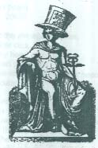 | The original incarnation of the Mad Milliner's Society was formed in the Soho suburb of London in 1878, although there is strong demonstration that the Society has its foundation in the London coffeehouses during the reign of the Royal House of Tudor; some adherents will even maintain that it in fact began much earlier, possibly as a Thoth-cult conspiracy in the days of Ramses II, Pharoahe of the 19th Dynasty. The primary constituents of the Society in 1878 were, supposedly, Robert Louis Stevenson, author of such classic works of adventure as "Treasure Island" and "Kidnapped"; Matthew Arnold, the great social critic; Mary Ann Evans, known as George Eliot; the Reverend Charles Dodgson, a humble author of children's storybooks; and later, the inestimable Rudyard Kipling. Around them orbited a number of lesser writers and luminaries. Oscar Wilde, though never having openly admitted it, is rumoured to have been a member as well. Two great exhibits were held for a select assembly of peers and contemporaries before the alleged demise of the Society in 1891, and two legendary literary collections were said to have been made. However, neither of these have ever been recovered and, thus their existence, in the opinion of the Society, has been discounted.

"Mercurie signifieth subelt men, ingenious, inconstant: rymers, poets, advocates, orators, phylosophers, arithmeticians, and basic fellowes."

Thus, the patron of the Mad Milliner's Society is Mercury, the messenger-god of Romans. The inscription emblem of the Society is that of Mercury wearing winged sandals, known also as talaria, representing his energetic nature; bearing in one hand the Caduceus, and the other a lyre, representing his desire to bring the realms of science and art together; and on his head, a large, floppy felt hat canted at a jaunty angle, representing his personable sense of self-redicule. The Society's motto is Non Ex Quovis Ligno Mercurius Fit, But You Can Damn Well Try.

Although the Society has been attributed with acts of public terrorism and mischief, and in many cases conspiracy, anarchy and Communism, these must be reasonable discounted. It is merely an open-minded forum for discussion, debate, and artistic expression, in which any subject, no matter how socially reviled or unaccepted, is considered fair game.

Additionally, it must be noted that contrary to popular belief, no member of the Society is currently, nor has ever suffered from St. Vitus' Dance.
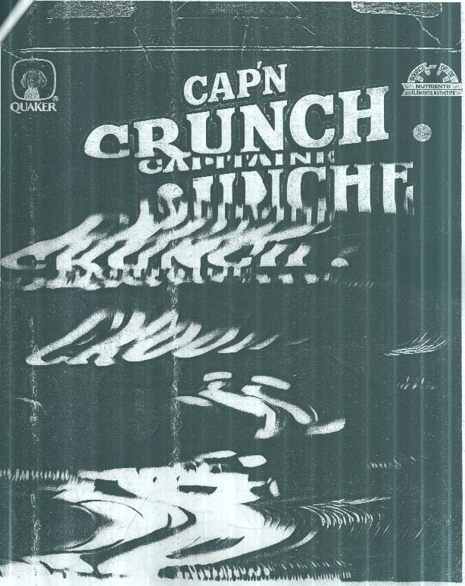
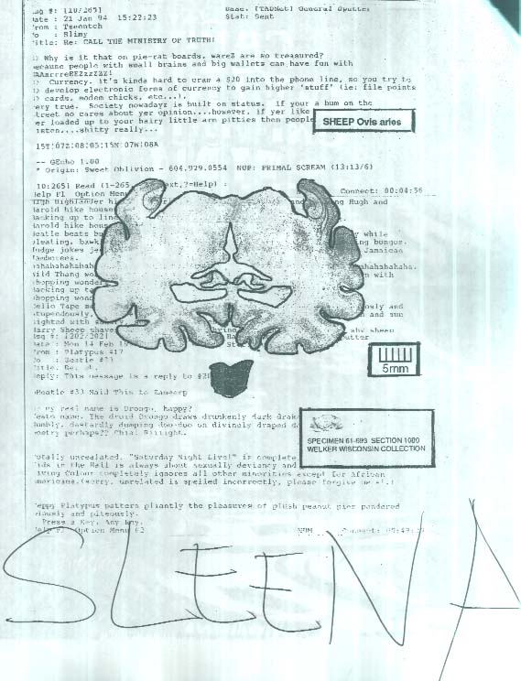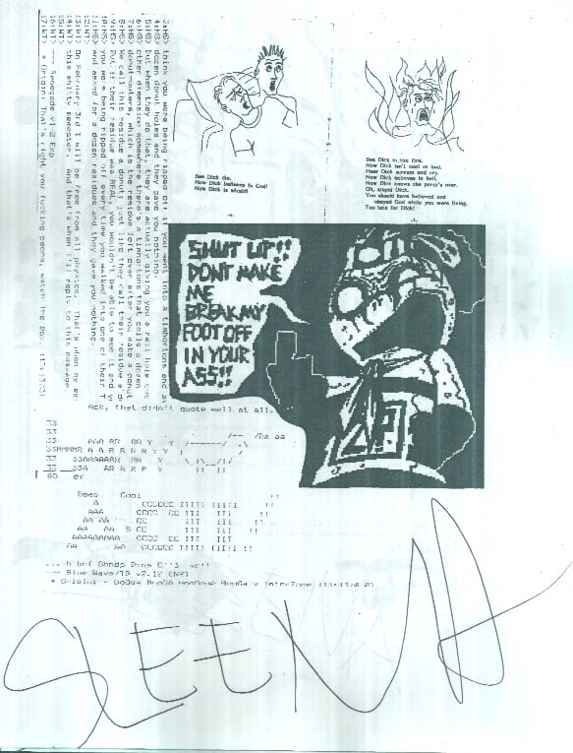
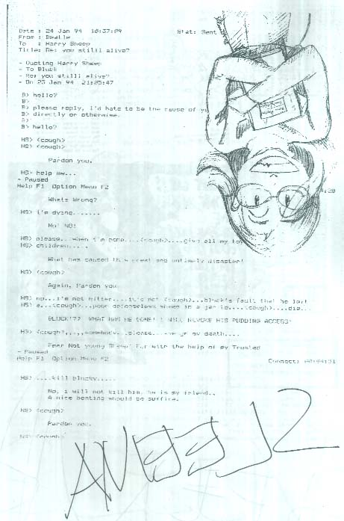
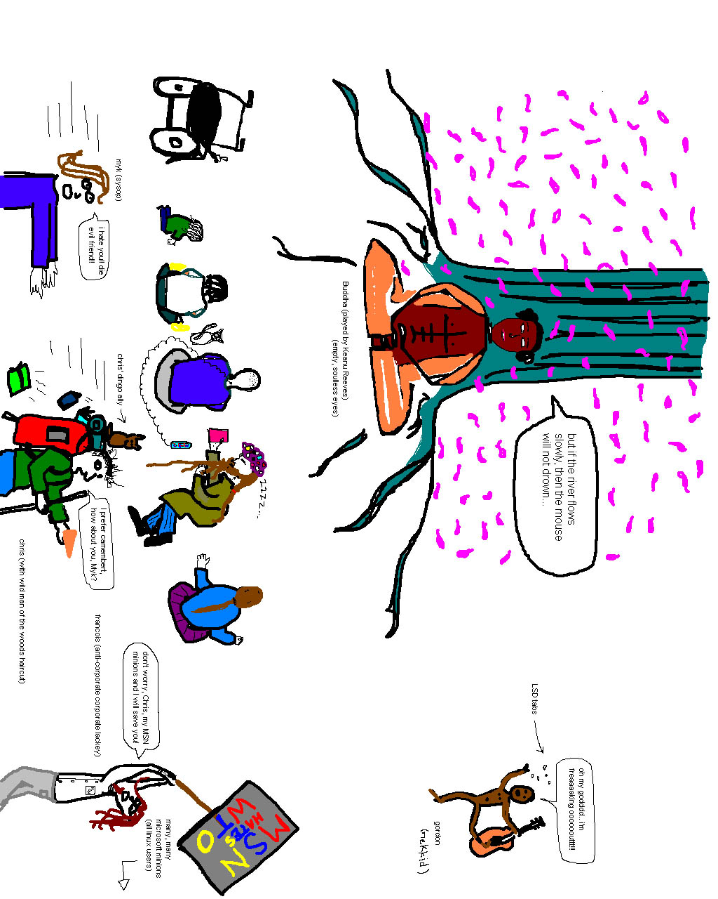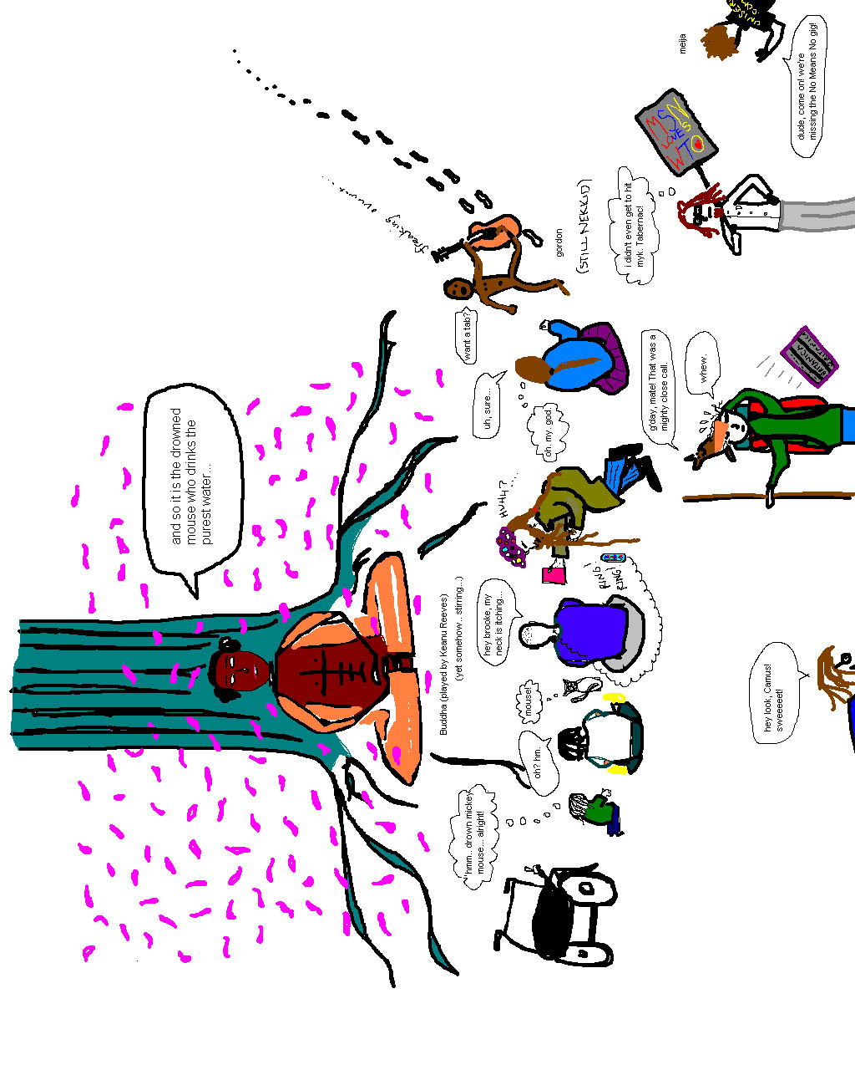
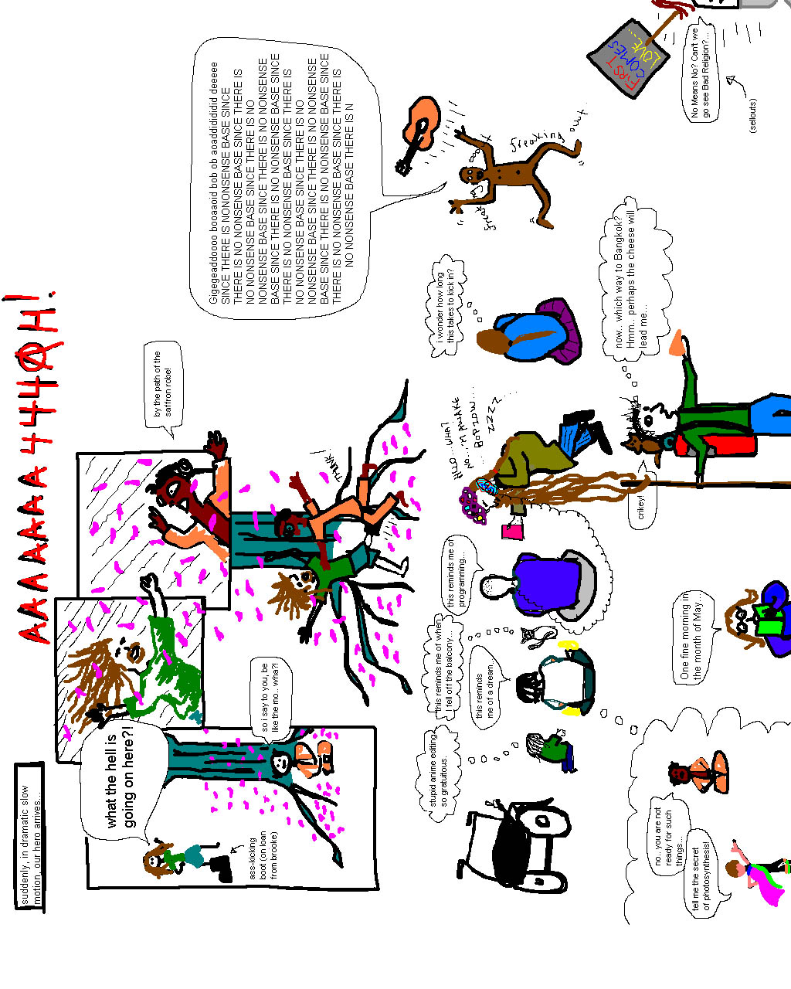
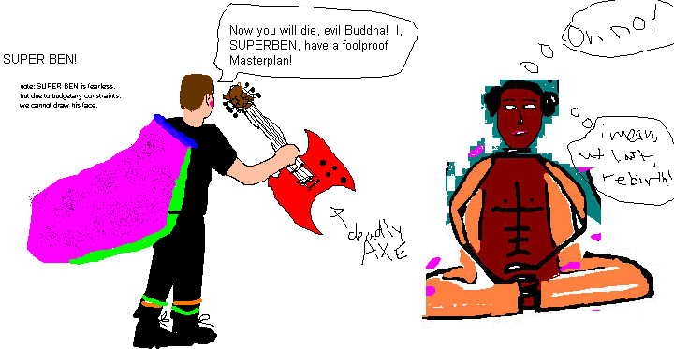
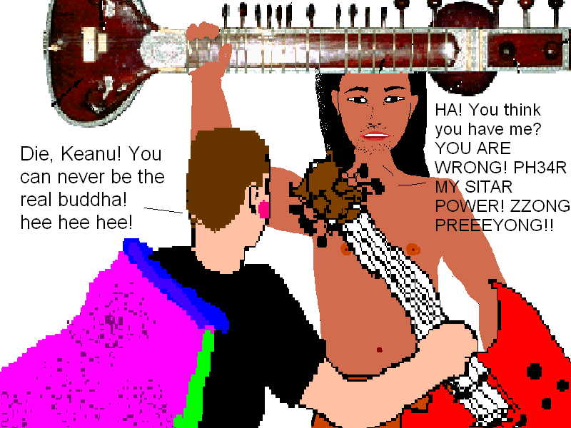
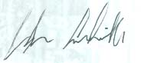
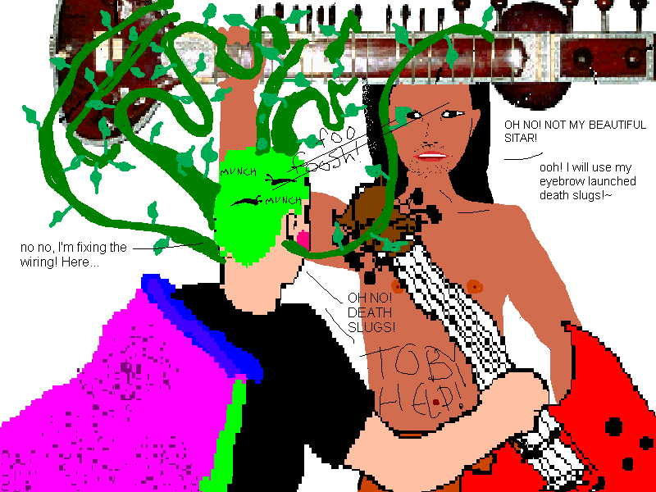

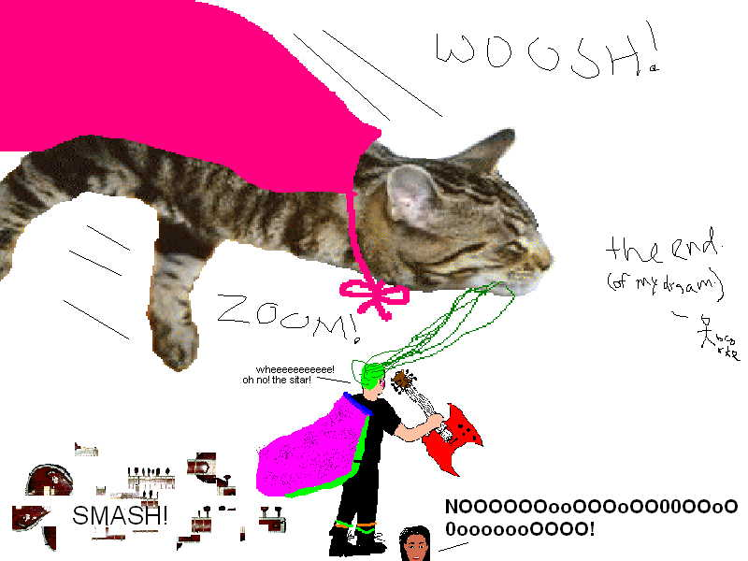

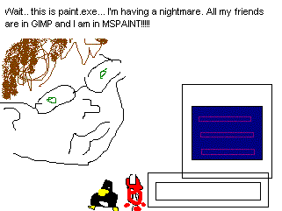
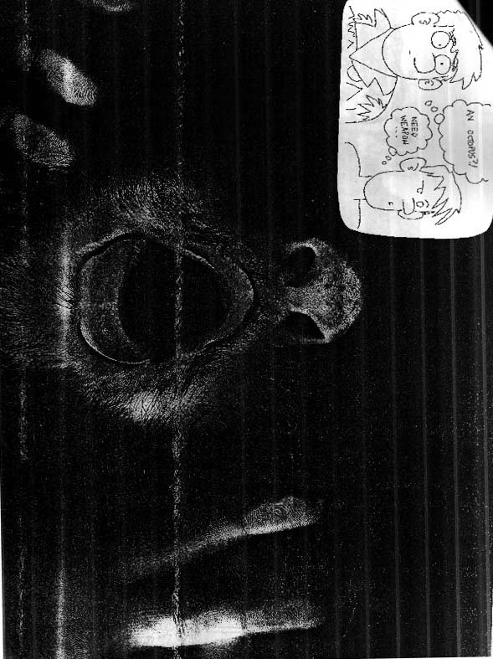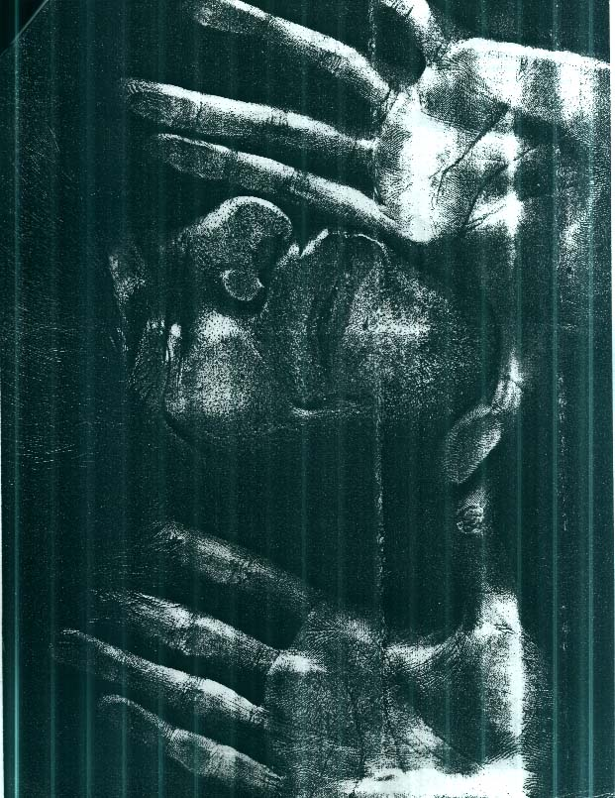
ANSI artscene reflections by Corinthian of Dark

The first ansi art I looked at was an artpack released by Integrity, a Vancouver-based group that was formed in late ’94 and lasted until late ’95. I was immediately inspired to try my hand at this incredibly unique medium. 8 years later, the ansi art scene is on its last legs (to put it generously), and the last pic I started 3 or 4 years ago still sits on my hard drive, unfinished. ... (1/4)

for TLA :

Just as people feel that they don’t make movie stars like they did in the ‘30s and ‘40s, I feel that groups like Integrity and Legend represented the pinnacle of the art scene. Perhaps it’s because the mystique and thrill faded as the emergence of the Internet (and in particular, IRC) allowed artists to get to know each other. I soon realized they were just regular people like my self. ...

for SUPER:

Because of the infancy of the Internet at that time, along with spatial distance, I never got to know the likes of Darkforce, or Questor, or Nitnatsnoc. They were nothing more to me than a mysterious name and incredible pieces of art. So to me, they’ll continue to live on as ansi gods.

for CLOCK:

45. A bit of Frank Miller style for you with a Dark Illustrated promo. (4/4)

Do not be alarmed. This page would ordinarily be a high-definition piece of lobster pornography, but switches back to this text whenever you are looking, using a high-tech context-sensitive backwards-time-projectotron whose workings your minds are yet too savage and unruly to comprehend - ironic considering that you are anticipated to be its very inventors! Surely you have leaps and bounds ahead of you.

We have a problem. In our sun source timeline, by the year 2003 TABNet should have been well on its way to accomplishing its primary objective: total domination over the planet you now know as Earth, as well as secondary and tertiary objectives of achieving world piece and exporting expanded consciousness on a global and interspecies scale. We don't understand why it is you have squandered your advantageous starting position at the expense of an investment in the future of the whole planet, but it is perhaps not too late to recoup and renew the impact your select, chosen few must have on the planetary psyche. As stated in the sacred texts of E-Sheep we are seeing you as The Guy We Almost Was. Perhaps through indicating to you your future accomplishments according to our timeline we can get the mission back on track and point you in the right direction. Failing to heed these directives would jeopardize the entire chronological continuum, ours as well as yours, besides which: wouldn't you really rather live in this world than yours? Make it happen. Some events we register as having occurred in both our timelines; in regards to the remaining items, you just somehow managed to drop the ball. These setbacks aren't necessarily permanent, but by permitting your attention to wander you run the risk of losing track of the destination you had initially set out to attain.

- 94.02.20 - 17:00, 20 February - Matt Alan and Drongo Kcerb, aka beatle, aka (please see attached for full list) are observed hobnobbing with Nettwerk recording artist Sarah Mclachlan, who he persuades to greet TABNet. It is rumoured among fans that the song "Building A Mystery" off her 1997 album "Surfacing" addresses a tempestuous relationship between her and Gordon sometime in 1995. Apparently she was not as good a lay as the cabin boy.
- 95.03.05 - Celebrity gossipmongers are scandalized when Magik Elvis and Bjork, a match seemingly made in heaven, call it splits. This proves to do little to slow their incessant coupling.
- 95.94.31 - Rowan Lipkovits, a.k.a. Cthulu, a.k.a. The Happy Flower Man, throws up his hands on MiSTiGRiS and the entire ANSI art scene after admitting and demonstrating that he clearly has no aptitude or place in it, leaving instead to pursue his true calling in the world of international finance.
- 95.05.31 - International markets collapse; Vancouver stock exchange shut down by regulating commissions.
- 96.06.28 - Following some undiplomatic words at an international cultural event, Emil Saroyan begins his longstanding rivalry with the estate of L. Ron Hubbard - a feud beginning with his hospitalisation and culminating in far more sinister affairs. Damon Macmillan scoops the attention of the scandalised audience, mounting a public speaking career that would never amount to much on this side of the water - but he was big in Japan.
- 96.11.14 - Renowned science-fiction author William Gibson admits that the plot to his book Idoru was lifted almost wholesale from a lucid dream posted by Purple Haze.
- 97.09.01 - Amiga-based .MOD-tracking group EuphoniX tears up the college radio charts with their breakout hit Let's Get Out Of These Monkey Suits, preparing the ears of the nation for the electronic onslaught that would follow with Robert Miles' Children, Moby's Play, djjj's Dogs of War: a soundtrack for ICE Online, and Crapnotronic's influential tribute album of remixes of seminal tracks from the Happy Fetus Records crew at the Pelvis of Elvis. Proceeds from the Crapnotronic project go to star a label - Insaneacon Records - whose InterZone imprint attains notoriety when the ALL ANALysis album it publishes is banned in the USA based on its risqué cover art by Evil Iggy, whose visual arts career flourishes from the attention and culminates in an '02 retrospective at the Guggenheim.
- 97.04.15 - Dark horse candidate Zeitgeist Lebensraum, depicted by file photos everywhere juggling devil's sticks in a jester's cap, performs surprisingly well in an all-parties debate with his unprecedented flustered "You are ALL IDIOTS!" debating technique, culminating in his representing his riding in Victoria.
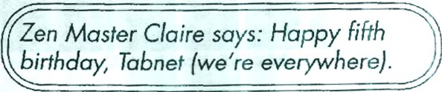
- 98.08.18 - the Night of the Long Pauses. A malicious hacker implants code in Shoreline, Delirium Tremens and other local chatboards gradually but steadily increasing the delay between the display of responses. Tragically, several dozen chatboarders starve to death before the tampering is uncovered. Evidence seems to point to an organization known as PsychoNet as being responsible, but being otherwise barely responsible enough to tie their own shoes they appear to have been set up as the fall guy by some third party. The case remains open.
- 98.08.30 - TABNet's 5th anniversary is celebrated in DiSCORDER magazine, in what would prove to be the first of their many grand and renowned media appearances.
- 98.09.06 - according to expurgated records later found, on this date a secret society calling itself the Great Cone Empire ("novus ordo spifforum") succeeds in the execution of a ritual exercise whose purpose and intent had been forgoten; through the illicit application of traffic cones the group made efforts to turn the downtown heart of Vancouver into a CPU, harnessing the movements of individual vehicles as electrons, in ceremonial hopes to streamline and observe the thoughts of the City. Remarks recovered from a partially-destroyed manuscript suggest that on this night, some modicum of success in this venture was at least partially attained, resulting in the disbanding of the order and the scattering of its members.
- 98.11.29 - Rocketing to heavy rotation on music television, a Rolling Stone review of the ponderous TABNet rock opera - an unwholesome love child between influences of Frank Zappa, the Grateful Dead, Mike Oldfield and God Is My Co-Pilot - claims the band's emergence from an on-stage vat of chocolate pudding while the audience is simultaneously showered with ice water and electrically shocked through their seats, as the most gloriously self-indulgent moment in rock 'n roll performance history. (It prefers the subtle nuances of the openers, Makeshift and Zeke the Wonder Nugget, especially the Mexican penguin costumes of the latter.) The review is pulled and never published after managing editor Hunter S. Thompson gets into a fistfight with Toxic Cockroach, who sneaks into their offices and gest in the first blow with a makeshift blackjack comprised of a Super Nintendo Entertainment System in a garbage bag.
- 98.12.15 - tHE fIFTH mOON oF sPORKLENOC is listed by the Utne Reader as the third-hippest neighborhood in North America, after the WELL and Yaletown.
- 99.04.15 - Favourite Zeitgeist is overturned at the Federal Federated Antiauthoritarian Smash the State Party leadership convention, where his sophistry and rhetorical tricks are overturned by Myk Whyte's "ASSHAT!" tactics. Mr. Whyte (who bizarrely insists on being referred to as "sOEMA" in this political context) becomes the most vivacious Speaker of the House in the whole history of the position.
- 99.06.18 - bastardcorp.com, the dotcom e-commerce venture started by TABNet (standing out with an italicised dot), is featured on the cover of Wired magazine. Despite having no business strategy, their "angry fruit salad" 16-colour ANSI design aesthetic fits well with that of Wired's layout department. By august there are no fewer than 15 foosball tables in the office and sinister Mindstorm-controlled arachnids prowl the cafeteria.
- 99.10.12 - Dog trainer Bob Eden found dead under mysterious circumstances. Despite appearances of foul play, the Delta homicide unit eventually declares the death, whose court order suppressed details involved sex toys and a pack of dogs, a messy suicide attempt. Investigative journalists will determine that his head was split into three (3) pieces with an axe. Constable Dennis Thiessen of the Vancouver Cybercrime unit will skip town after a signed glow-in-the-dark tie-dyed TABNet T-shirt is slipped through his mail slot.
- 99.11.18 - the TabHouse is featured in a CBC documentary illustrating the plight of the down and out in Vancouver's Downtown Eastside. Appalled at the living conditions depicted therein, Canadians open their hearts and wallets and a massive cash infusion enters the area, largely leaving through peoples' noses.
- 99.12.31 - Y2K. The lack of 4-digit date compatibility with Renegade, Telegard, InterMail, DesqView and FrontDoor would have been a profound stumbling block for TABNet had they nto long ago adopted proprietary software (with a sassy attitude that talked back when provided with unwanted input.) Unfortunately, while Tradewars 2002, BarneySplat and Legend of the Red Dragon are successfully ported, they are sidetracked by the modern Intel divide-by-zero error for programs compiled from Pascal, so the regional hub is left archaic ten years back in 1990.
- 00.01.21 - Kevin Mitnick, aka Condor, is released from imprisonment after being held for five years without charge. In a similar gesture of goodwill towards trailblazers of the electronic frontier, a wide-necked youth, who cannot be identified under the Youth Criminal Justice Act, is arraigned of property damage charges following his laying and detonating of demolitions charges, following instructions from the Jolly Roger Cookbook downloaded from Stonehenge BBS and with assistance from equipment stolen from BC Tel vans, in and along major Rogers Cable switching stations. Open season effectively declared on providers of major corporate media, info-anarchists intimidate them out of town following a casual demonstration of UTV's vulnerabilities by a man identified only as "the d0ctor". Long-reaching ramifications of this legal precedent result in an increase in public discourse both online and off, producing an agora of ideas in which are debated hot topics such as abortion and the merits of tube socks vs. heeled socks.
- 00.05.28 - The Saga of Samson-8, a sci-fi RPG thriller, is released by Frandroid Productions for the ill-fated Sega Flustercuck platform, but its adherents keep it alive for decades to come through emulation, opensource reverse-engineering and fan fiction.
- 01.05.18 - Razor 1911, the Cult of the Dead Cow, Future Crew and ACiD, Inc. perform an extraordinary merger whose resultant keiretsu, Omnicentroplex Unlimited, is brokered by bastardcorp.com into a subsequent merger with NetscapeAOLTimeWarner, ebay, Amazon.com, Slashdot, Napster and Google. It doesn't make anyone any money, but the porn flows freely and in abundance. Once it's apparent that the whole bloated venture is approaching a critical mass of obsolescence, the works are sold to Bill Gates for a dollar. The infomedia behemoth causes Microsoft to implode in on itself (literally; much of Redmond disappears one night leaving behind only a smoking crater). Usage of BeOS and OS/2 Warp skyrocket.
- 01.04.15 - sOEMA suffers a grand upset at the Bugger All This Party leadership convention, where his antiquated style of discourse, trapped in its Parliamentary niceties, fail to compete favourably with Gordon Breckenridge's erudite "SHUT THE FUCK UP" approach. sOEMA steps down, while Gordon's unorthodox style leads the party to Official Opposition status in Ottawa.
- 02.01.01 - the MindLink! BBS list reports over twenty thousand entries in the Lower Mainland, ten thousand of which are redundant nodes for Basic'ly Computers. The new area code 778 is set aside for exclusive use by bulletin board systems.
- 02.06.28 - The Complete Collected Crazyshit enters the New York Times' bestseller list, where it remains for 218 weeks.
- 02.09-23 - In an incident reminiscent of outbreaks of epileptic attacks following airings of the Pokémon cartoon, over three hundred people are sent to the hospital suffering from food poisoning and extreme gastronomic distress after preparing and consuming recipes offered on an unexpurgated syndicated episode of the Imbibe cooking show. New varieties of egg nog are engineered that cannot mix with macaroni and cheese, regardless of how hard you try, and Blue can no longer be sold without a license.
- 03.04.15 - Gordon's dodgy verbal style is challenged and outclassed by the insidious "SO, TELL ME ABOUT YOUR PROBLEMS" style employed by DR. SBAITSO, who goes on to lead the People's Glorious Network Community Party not only to government but, within ten months, also through a calm and peaceful secession of the 604 as a Free City where the raves never stop.
- 03.05.01 - After 20 years of operation, FidoNet shuts down, having fulfilled its historical mandate of providing nascent tabbers an odious example of the irrelevance of traditional top-down hierarchical authority structures in the noosphere.
- 03.11.14 - Perpetual Dream Theory's D-A-D-A song becomes the national anthem of the sovereign state of Sixophoria. Before its coat of arms - argent 2400 external modem rampant langued gules on a field blazoned per fess engrailed azure and sable before crossed foam boffers - Minister of Percussion $hawn Killaly performs its inaugural solo on the electric marimba, toy piano and circular saw live to a webcast audience of 150 million through CiTR 101.9 fm.
- 03.12.18 - Benny's Bagels is designated a World Heritage Site by the United Nations.
- ... some time later...

- 12.01.01 - Melting of the polar icecaps realizes ancient Mayan predictions regarding the End of the World. The snotty-nosed indolent youth of the world, largely occupying underwater arcologies, complain that the brackish interference with their satellite connections increases the latency on their networked rounds of Sid Meier's Out of Grand Theft SimHack Island: the Scorched Alleycat of Aragon for Glory and Die of the Azure Bonds of Persia in the Dark Masters Expansion Pack. These catastrophic disruptions prompt the emergence of strange powers in a fully mature Evan Monroe, trained in arcane and esoteric arts from a young age, destined to assume power as the Kwisatz Taberach. Filled with strange new energies, he rises to his new responsibilities by going "TABNet? This sucks. I'm going backpacking in Australia for a few years."
- 12.03.18 - While issue number 2 of Concrete is released, the procrastination study in Spoon remains ongoing. A polybagged copy of Dream Factory #1, in mint condition, sells for over triple its original value at $6. On the archaeological front, versions of previously unknown verses of the Bible of Nuiwanda thought lost forever are recovered from underwater buried urns located near the Dead Sea. Among other parables is included an example of what happened when Abraham tried to box over his own lines.
- 13.11.14 - For the 20 year celebrations of TABNet, Big Time decides he's ready to show up to a meet - the group meeting up to see the first showing of Devious White Bug IV: Deviate Harder. About this time, a user finally attains the last user level on the Underground Subway. Unprepared for this eventuality, the computer panics and sends NORAD armament codes through what remains of the ARPANet, activating what once were nuclear missile silos. This perplexes to no end the partiers in what are now modified Silophone chill-out rooms.
- 13.12.21 - As part of Solstice celebrations, a national tea-candling festival produces illumination visible from outer space, where they attract the attention of passing extra-terrestrials coincidentally orbiting in spacecraft resembling nothing so much as giant peanut butter cups. This meeting marks the maturation of our species and the beginning of history, regardless of what Hegel would say.
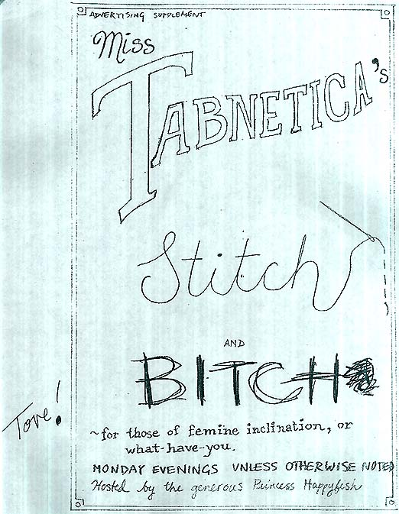
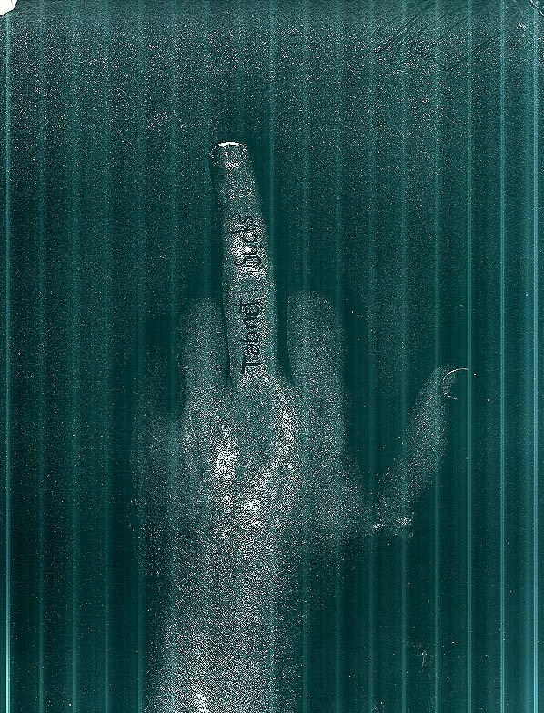
Footnotes / alt text:
1. cover -- was a limited edition of 38, each featuring a different EPYC and a truncated tabnet business card. For the web - load a random EPYC, superimpose a card and ## - / infinity (counter), make linky?
2. – contained nothing (were prepared by chris and myself separately, doy) but I collected signatures on mine and, well, here they are.
3. Tab / net * * monkey fondulator does not include batteries
4. Tabnet: (insert Life in Hell strip here) I love you.
5. table of contents
6. Tina's collage (mine is signed) : legend?
7. Gomi's "Shut the Fuck Up" macro attack page (mine is signed)
8. Frandroid – the spice must flow! (signed)
9. Ziola’s word search (legend?) (signed)
10. Soema's submission, ode to an open hand on her thigh (signed)
11. casa del sol concert ad (signed)
12. courtesan quotes me talking about the pranksters
13. slimy reminisces
14. brooke collage pages: BC Transit spacebus, Evaporators flyer, Brooke bus, Feb '94 transfer
brooke collage page: picture of me woody and josh from below, starcon2 map, zk eel quote and arabic
brooke collage page more: AHOM card, how to identify thor comic (nitnatsnoc), chalk and salmon renaissance (talonswift), crowkeeper "missed all your spiritless and misguided angst",
funky shoes picture + caption "shoes at ten paces", dr. schwa picture, chris in a cape, wedding invite
15. meija's fireworks review. (signed)
16. dubaiwalla’s excerpts from HHGTTG
17. dubaiwalla map, Selected quotes from Tabnet:
18. AHOM excerpt from "Have Penguin, Will Travel", Rowan Lipkovits' 3-day-novel of... 1996? (Cthulu)
19. chris' collage -- doodles, ahom tab and smoked granola cards, exquisite corpse, whale with rifle, concrete sistine chapel, sam and max comic. dr. benway quote: Dr. Benway is operating in an auditorium filled with students: "Now,
boys, you won't see this operation performed very often and there's a
reason for that.... You see it has absolutely no medical value. No one
knows what the purpose of it originally was or if it had a purpose at
all. Personally I think it was a pure artistic creation from the beginning." (I think it’s up in his bedroom at his parents’ house, the contents of which warrant a page (if not an entire zine) of their own.)

See also FINGER.GIF from the Concrete Archives – in full colour:
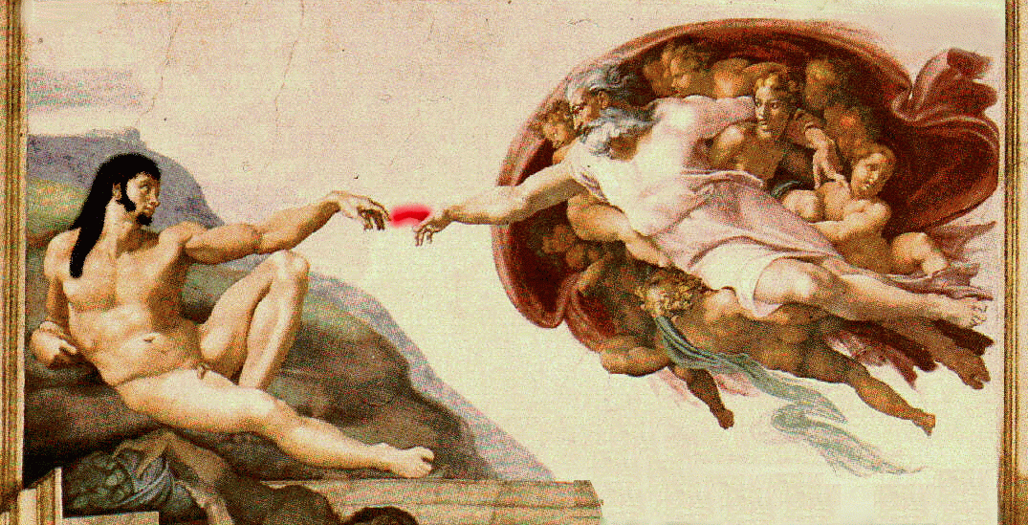
– chris, exquisite corpse
20. coyote poems 1
21. coyote millennial mad milliner’s society
22. chris - cap’n crunch photocopy from blender 27.5
23. selina collages 1-3 (autographed)
24. zw - tabnet vs. Buddha 1
25. ben vs. Buddha 4-5 (signed) plus josh’s? nightmare zongzong.
26. chris – cth photocopy from blender 27.5 plus panel from gravity’s rainbow comic, chris – josh photocopy from blender 27.5
27. corn – TLA, SUPER, CLOCK, DARKILL
28. ct - ~^*#@CHRONO-SPATIAL ANOMALY DETECTED!@#*^~. Bonus copy --
* 1992 06 March - Michaelangelo virus set to trigger.
1993 30 January - Rusty 'n Eddie's busted Russell and Edwina Hardenburgh
29. tove - miss tabnetica’s stitch and bitch ad, signed
ADVERTISING SUPPLEMENT
Miss TABNETICA'S
Stitch and BITCH
~ for those of feminine inclination, or
whathave-you.
MONDAY EVENINGS UNLESS OTHERWISE NOTED
Hosted by the generous Princess Happyfish
30. chris: tabnet sucks, signed.

bonus anniversary meet content - happyfish / putter crosswords, tabx card, yes / no letters, big fuckling q, scavenger hunt list / rules, barrett's privateers filk

fix: BETTER SCANS OF EVERYTHING (colour originals where possible) esp. tabnet I love you
souvenir programme font in table of contents
squareify wordsearch,
Wwwt op icon.
Figure out how to Convert full ansis
Get full telepoetics URL, figure out which font(s) used in header and text of timeline

http://www.e-sheep.com/almostguy
http://web.cs.mun.ca/~patrick/sarah/chat/talk1.html
http://www.kin.bc.ca/jvh/EdNAv/GATEWAYS/PUBL/CPO/SECTORS/ARTS/HA ... (obscured)
http://www.chartattack.com/charts/college/oldcamp/sep97/9709camp1.txt

